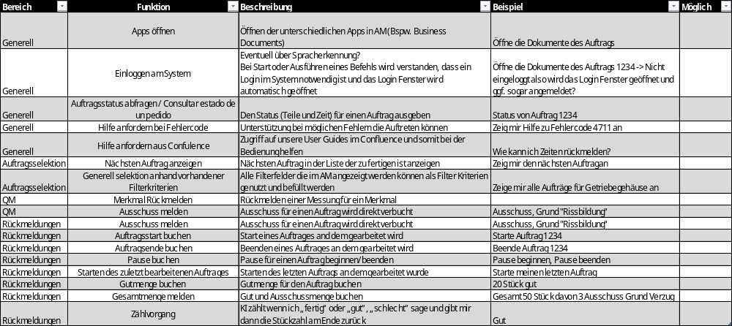
1. Open Apps / Apps öffnen
Instructions
- Open SAP Fiori Launchpad in Google Chrome.
- Log in using your username, password, language, and client (if required).
- From the Home screen, locate the required application tile (e.g., Business Documents, Capture Production Data, Advanced Manufacturing).
- Click the application tile to open it.

2. Log into the System / Einloggen am System
Instructions
- Open the SAP Fiori URL provided by your administrator.
- Enter:
  - User name
  - Password
  - Language (if shown)
  - Client (if shown)
- Press Log On.
- If the system requires your personnel number, enter it when prompted inside the Advanced Manufacturing module.

3. Check Order Status / Auftragsstatus abfragen
Instructions
- Open Advanced Manufacturing.
- Enter your selection criteria (order number, work center, material, etc.).
- Click Go.
- The list of operations will show:
  - Quantities
  - Status (“in process”, “done”)
- Select the desired operation to see detailed status.

4. Request Help for Error Codes
Instructions
- When an error message appears, note the error code.
- Ask the system (voice, chatbot, or supervisor) "Show me help for error code XXXX."
- Review the help information provided on screen or via Confluence link if available.

5. Ask for Help via Confluence
Instructions
- From Advanced Manufacturing, select the Help/Confluence tile (if available).
- Open the linked user guide or troubleshooting page.
- Use the search bar to find your topic (e.g., “confirm quantities”, “view components”).

6. Show Next Order
Instructions
- Open Advanced Manufacturing and select an operation.
- Use the navigation buttons:
  - Next → shows the next operation
  - Previous → shows the previous operation

7. Select Orders Using Filter Criteria
Instructions
- In Advanced Manufacturing, click Adapt Filters.
- Add, remove, or activate filters such as:
  - Work center
  - Material
  - Order
  - Start date
- Press Go to update the results.
- Save the filter view if needed using View → Save.

8. Confirm a Quality Characteristic (QM)
Instructions
- Select the required operation.
- Choose the tile for QM characteristic confirmation (if configured).
- Enter the measurement result.
- Press Confirm to save the characteristic.

9. Post Scrap for an Order
Instructions
- Open Capture Production Data (CP).
- Select the operation.
- Click the Scrap confirmation button.
- Enter:
  - Scrap quantity
  - Scrap reason code (mandatory)
  - Text (optional)
- Press Confirm.

10. Post Yield (Good Quantity)
Instructions
- Open the CP app.
- Select the operation.
- Click Yield.
- Enter:
  - Quantity
  - Text (optional)
- Press Confirm.

11. Post Rework
Instructions
- In CP, open the operation.
- Click Rework.
- Enter:
  - Rework quantity
  - Reason code
  - Text (optional)
- Press Confirm.

12. Start an Order (Start of Work)
Instructions
- Open CP → select operation.
- Under time confirmation:
  - Click Setup, Processing, or Teardown, depending on what you want to begin.
- The active phase will be highlighted and time recording starts.

13. Finish an Order (End of Work)
Instructions
- In CP, go to the active time recording section.
- Click Finish.
- Ensure actual end time and date are correct.
- Press Confirm.

14. Start and End Pause
Instructions
- In CP, select the operation.
- Click Pause Start to begin the break.
- After returning, click Pause End.
- System will log the pause automatically.

15. Start the Last Edited Operation
Instructions
- In CP, look for the tile Start Last Operation (if configured).
- Click the tile.
- The system will reopen and start time tracking on the last processed operation.

16. Post Good Quantity for an Order
Instructions
- Open CP.
- Select the operation.
- Use the Yield button.
- Enter the total quantity (e.g., 20 pieces).
- Confirm the posting.

17. Post Total Quantity (Yield + Scrap)
Instructions
- Open CP.
- Select the operation.
- Use the Quantity Confirmation panel.
- Fill in:
  - Yield
  - Scrap
  - Reason code (mandatory for scrap)
- Press Confirm.

18. Counting Process (Using AI or System Counter)
Instructions
- At the end of an operation, the system may request confirmation of total pieces.
- Indicate verbally or manually:
  - "Good"
  - "Bad"
  - Or specific numbers
- The system returns the final counted amount.

19. Open Business Documents
Instructions
- Select an operation in Advanced Manufacturing.
- Click the tile Business Documents.
- Choose the desired document.
- Depending on customization:
  - It opens in new tab, or
  - Opens in split screen, or
  - Downloads automatically (PDF)

20. View Components
Instructions
- Select an operation.
- Click Components.
- Use:
  - Show All to see all components of the order
  - Show Deleted for removed items
- Open documents attached to components using the View Document button.

